**Technology.** A standard photocatalytic filter consists of 5 stages of air purification:

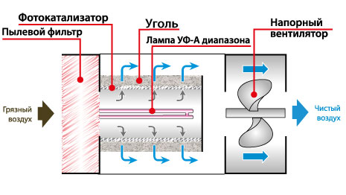

1. Dust filter
2. Photocatalyst TiO2
3. Electrification of soot and dust molecules and sticking in a carbon filter
4. UV lamp
5. Pressure filter

Harmful organic and inorganic pollutants, bacteria and viruses, are adsorbed on the surface of TiO2 photocatalyst deposited on a porous carrier (photocatalytic filter). Under the action of light from a UV lamp, range A, their organic and inorganic components are oxidized to carbon dioxide and water. In fact, photocatalysis provides a unique opportunity to deeply oxidize organic compounds under mild conditions.

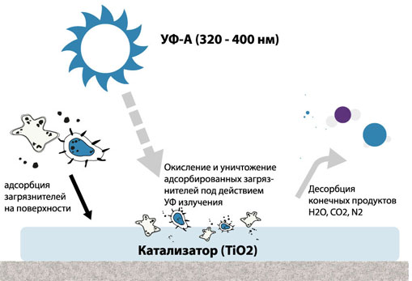

In switching lamps, lighting technologies were used such as: electromagnetic relay V23063-BI036-2102, two batteries for the accumulation of energy transmitted from the solar battery 3W 145 * 145MM, and four 2-watt LEDs.

The wind generator turns the dynamo and thereby charging the battery to provide power to the mini-pump in the filter.

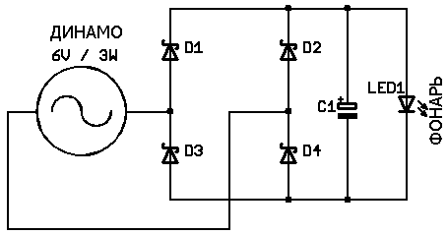

**Research results.** The prototype was tested on the territory of the “Nazarbayev Intellectual School of Chemical and Biological Direction of Almaty” and the results of the research were as follows:

|  |  |  |  |  |
| --- | --- | --- | --- | --- |
| № | Substance | Concentration to  start of experiment | Concentration after end of experiment | % conversion gas phase pollutant |
| 1 | Ammonia | 14.9 ppm (10 mg/m3) | 0,4 mg / m3 | 96 % |
| 2 | Hydrogen sulfide | 0,009 ppm (0.012 mg / m3) | 0,0003 mg / m3 | 97,5 % |
| 3 | Phenol | 0.05 ppm (0,2 mg / m3) | 0,006 mg / m3 | 97 % |
| 4 | 3,4-benzpyrene (benz (a) pyrene) | 1×10-7 ppm (1×10-6 mg / m3) | 1×10-9mg / m3 | 99 % |
| 5 | Benzene | 7.8 ppm (24 mg / m3) | 0.2 mg / m3 | 99,2 % |
| 6 | Pyridine | 0,06 ppm (0,2 mg / m3) | 0.001 mg / m3 | 95 % |
| 7 | Sulfur dioxide | 0.3 ppm (0,6 mg / m3) | 0.42 mg / m3 | 15 % |
| 8 | Hydrogen cyanide | 0.1 ppm (0.1 mg / m3) | 0.0002 mg / m3 | 99 % |
| 9 | Methane | 228 ppm (144 mg / m3) | 0,87 mg / m3 | 99 % |
| 10 | Xylene | 2 ppm (8 mg / m3) | 0.25 mg / m3 | 97 % |
| 11 | Toluene | 10,7 ppm (39 mg / m3) | 0.79 mg / m3 | 98 % |
| 12 | Sulfuric acid | 0,12 ppm (0.5 mg / m3) | 0.28 mg / m3 | 44 % |
| 13 | Ethylbenzene | 3 ppm (1,2 mg / m3) | 0.02 mg / m3 | 98 % |
| 14 | Naphthalene | 0,03 ppm (0.12 mg / m3) | 0.0024 mg / m3 | 98 % |
| 15 | Carbon monoxide | 44 ppm (35 mg / m3) | 0.9 mg / m3 | 99.9% |
| 16 | Dimethylamine | 0017 ppm (0.033 mg / m3) | 0.0019 mg / m3 | 94 % |
| 17 | Formaldehyde | 0.09 ppm (0,1 mg/ m3) | 0.001 mg / m3 | 99% |

From this table it can be seen that the amount of benzene, carbon monoxide, formaldehyde and 3-4-benpyrene has generally decreased.